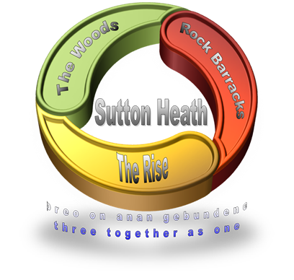
SUTTON HEATH PARISH COUNCIL
NEWSLETTER

Sutton Heath Parish Councillors:
Chair: Louise Chalklen 07846 474604
Vice Chair: Nick Ward 01394 461447
Councillors: Roy Hirst 01394 460411
Rob Merriam 01394 461385
Issue No 35
Jan/Feb 2022

Adelle Betteridge 07814 388151
Elaine Prokopowycz 07493 873942
Sharon Hadley 01394 461140
Parish Clerk: Marion Merriam 07541 747679

Email: suttonheathclerk@yahoo.com
Website: http://www.suttonheath.onesuffolk.net/
_____________________________________________________
If you are in any need please contact the Parish Clerk or one of the Councillors above
USE IT - SO WE DON’T LOSE IT:
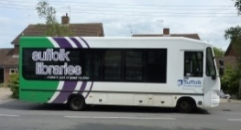
- The mobile Post Office – every Thursday 9-10am
- The mobile library - fourth Wednesday of each month 12:00-12:20pm. If you have a book out on loan from Woodbridge library you can return it to the mobile library.
- The Moving Plaice fish & chip van - Mondays 16:00-19:30. For orders call 07493 359269.
- The Burger Van: every Thursday from 4pm
- No 71 Bus Service to Woodbridge - There is a timetable at the bus stop

FOR YOUR INFO:
- Poppies Coffee Lounge - Barnsdale Centre – 9:15am-2pm, Mon-Thurs
- Rockies Trading Post & Gift Shop - Barnsdale Centre - 9am-2pm Wed/Thurs
- Book Swap room - Barnsdale Centre - 9am-2pm, Mon-Thurs
- Rock Church – First Sunday of each month at 4pm in the Barnsdale Centre.
- Sutton Heath Ladies Group meet on the second Monday of each month. Please phone Eileen on 421010 or Pauline on 420910 for information on future events.
- Community Store hours: Mon-Fri 7am-8pm; Saturday 8am-6pm; Sunday 8am-5pm
COMMUNITY EVENTS (suttonheathevents@gmail.com):
- Crochet/Knit & Natter: Making Remembrance poppies for Rock Gardens – Wed 2 February in Barnsdale Centre 1-3pm and then monthly thereafter. Tuition, wool and needles available!
- Baby Classes: Free 5 week course for 0-6 month olds. Thurs 24 Feb in Barnsdale Centre
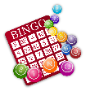
- Bingo Night: Thursday 10 February (if enough people) Community Centre, Rm 8 at 7:30pm

- Quiz Night: Friday 4th March, 7pm at Alan Crompton Hall

- Pilates Class: Crompton Hall – All levels welcome: Mondays 19:45-20:45; Thursdays 10:00-11:00
- Yoga: for all ages & levels - Community Centre Rm 9 - 10am-11am (Tues);
6.30-7.30pm (Thurs). Contact Anne on 07471 471156 or annedeane.yoga@gmail.com

The games area is available for any Sutton Heath resident to use. There is no booking facility. The netball nets will be dusted off and put in place soon …

The skate park is for the use of all residents and their families.

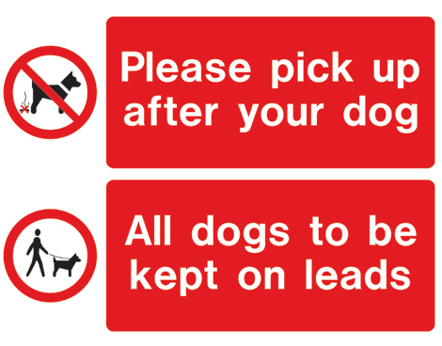
Dog Owners - At the parish council meetings this subject is raised regularly as a complaint. Please pick up after your dog. Thank you.

SNIPPETS FROM THE PARISH COUNCIL MEETING:
- Cllr Mallinder said that waste collection will be changing in the future
- Cllr Reid said that SCC are looking to increase expenditure to allow more to be spent on mental health support, Suffolk Fire & Rescue services and also 60,000 street lights will be replaced in due course with LED ones which will mean an eventual saving
- Carpenter making table with worktop surface to replace cooker in Crompton Hall
- Three recycling/general use bins to be ordered: for Ipswich Close playpark, Rock Gardens and at the Community Store
- First Aid courses to be offered to residents to fit in with a Good Neighbour Scheme and Emergency Plan which are in the process of being set up
- Chair has drafted a letter to residents explaining the Emergency Plan and asking for volunteers
- Queen’s Platinum Jubilee: Sunday 5th June to be a community family picnic/village fete
- Queen’s Platinum Jubilee: Oak sapling with plaque arrives mid Feb for planting (Christmas tree already planted in garden)
- Rock Gardens: two fruit trees are to be replaced by Swanns Nursery also the two pieces of broken fencing
- Shrubs and bedding plants identified and to be planted in Spring
- New shed for Rock Gardens has been received
- Open Day at Rock Barracks is being planned for June

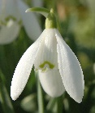
The next Parish Council Meeting will be held on Monday 7th March. The meetings are held at 7pm in the Barnsdale Centre. All residents are welcome.

