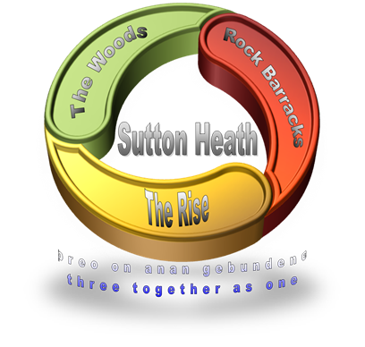
SUTTON HEATH PARISH COUNCIL
NEWSLETTER

Sutton Heath Parish Councillors:
Chairman: Colin Wearmouth 01394 420794
Vice Chairman: Nick Ward 01394 461447
Councillors: Claire Anderson 01394 809891
Louise Chalklen 01394 766576
Issue No 19
July 2019

Chris Hall 01394 461536
Roy Hirst 01394 460411
Rob Merriam 01394 461385

Parish Clerk: Marion Merriam 07541 747679 / suttonheathclerk@yahoo.com

The next Parish Council meeting will be held on Monday 9 September 2019 at 7pm in The Barnsdale Centre. All residents are very welcome to attend. If you wish a topic to be discussed please contact any of the Parish Councillors on the numbers listed above, or use the suggestion box on the back of the notice board opposite the Costcutter shop.

A brief summary of items discussed at the Parish Council meeting on 8 July 2019:
- Rock Gardens – the military have finished the demolition of the buildings; Swann’s Nursery will landscape the area in August;
- The community quiz night organised by Cllr Chalklen and Cllr Anderson went well and £119 was raised for Women-v-Cancer;
This Photo by Unknown Author is licensed under CC BY-SA-NC
- The DISH curry night event raised £558 for Project 21. Other community events are planned for after the summer, around October or November. It is expected that the next one will be a ‘child friendly’ disco;
- Cllr Wearmouth had received a communication from a resident who complained about the car noise created by a Greenways resident. This had already been reported to the District Council;
- Cllr Wearmouth said that the mobile post office had been up and running for a few weeks now and was found to be very successful. As always it would be good to continue to broadcast this service so that it will retain its popularity. Posters are in the Costcutter shop, The Barnsdale Centre and the community notice board;
- Cllr Andrew Reid said that there would shortly be an examination of all the bus routes in the region. There was risk of the subsidy on the No 71 service being reduced/withdrawn, resulting in the service being cancelled. Sutton Heath Parish Council, together with Hollesley Parish Council, are working together to try and secure an alternative bus service and, in particular, the No 800 Park & Ride service which currently runs to Rendlesham;
- It was noticed that the nets at the Multi Games Area and one of the specialist lights needs replacing. This will be arranged soon.
- The Parish Clerk mentioned that the parish website hasn’t been updated for a while - this will be attended to shortly.

SPEEDING ON SUTTON HEATH ESTATE
Speeding on the estate was discussed at the recent parish council meeting. All drivers of cars and motorbikes are reminded that there are speed limits within the estate so please adhere to these. There are children on bikes around so please slow down.

SUTTON HEATH SINGERS
This Photo by Unknown Author is licensed under CC BY-NC
On Saturday 29 June The Crompton Hall was packed for the choir’s annual concert. The title this year was ‘Music to Make you Smile’ - which the choir certainly did! It was a ‘cabaret’ style evening with a licensed bar plus refreshments and a raffle. There was a great audience and wonderful music from a very talented group of people directed by Micky and Abi.
Surplus money raised from the evening is to be divided between East Anglian Children’s Hospices and East Anglian Air Ambulance. Thanks to everyone who attended and supported the evening.
If you enjoy singing why not join the choir on a Thursday evening 7:30-9pm
(resumes 12 September after the summer break).
There is a varied choice of music and no auditions are required!
For more information contact Trish on 07766 230222.

CONNECTING COMMUNITIES
Demand Responsive Bus Service
Call: 01728 830516 (Monday to Friday 08:45 – 16:00) When you need to make a journey Monday to Saturday and there is no public transport available CATS can provide you with transport to access local villages or connect you to an appropriate bus or train link at Woodbridge or Melton.

MOBILE LIBRARY
This Photo by Unknown Author is licensed under CC BY-SA-NC
A wide range of books for adults and children
Every fourth Wednesday 12:00 to 12:20 in the Costcutter car park.
on the following 2019 dates:
18 Sept, 16 Oct, 13 Nov, 11 Dec.

MOBILE POST OFFICE
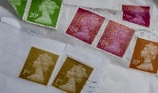
The mobile post office visits Sutton Heath every Thursday 8:30 – 9:30.
This Photo by Unknown Author is licensed under CC BY
This Photo by Unknown Author is licensed under CC BY-NC
It’s located in the car park near Costcutter.
They can do everything except deal with passports.
Great news for folks not able to get into Woodbridge easily.
So … let’s all USE IT OR LOSE IT!

SUTTON HEATH LADIES’ GROUP
A group of ladies meet on the second Monday of every month.
Please contact Eileen on 421010 for more info.

SUTTON HEATH COMMUNITY CHURCH
An informal service is held at 9:30am on the 1st Sunday of each month
in The Barnsdale Centre; followed by refreshments.
Everyone is welcome.

POPPIES COFFEE LOUNGE
This Photo by Unknown Author is licensed under CC BY-SA-NC
The best coffee around; the best small cakes around (baked by The Crazy Cake Lady); the best prices around (tea and cake only £2 on a Monday) so if you have never visited before you are missing out! Snacks also available.

Next door to their coffee lounge Poppies has a quiet ‘Book Swap’ room where you can browse a wide range of books and either sit and have a quiet read there
This Photo by Unknown Author is licensed under CC BY-ND
or take a book home.

