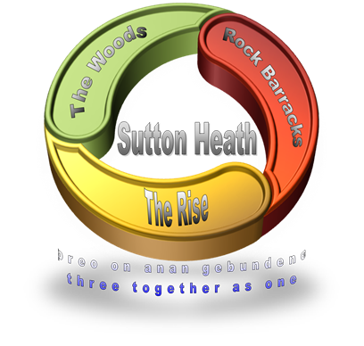
SUTTON HEATH PARISH COUNCIL
NEWSLETTER

Sutton Heath Parish Councillors:
Chairman: Colin Wearmouth 01394 420794
Vice Chairman: Nick Ward 01394 461447
Councillors: Claire Anderson 01394 809891
Louise Chalklen 01394 766576
Issue No 21
November 2019

Chris Hall 01394 461536
Roy Hirst 01394 460411
Rob Merriam 01394 461385

Parish Clerk: Marion Merriam 07541 747679 / Email: suttonheathclerk@yahoo.com

USE IT OR LOSE IT:
- The 71 Bus Service has been restored with effect from Monday 18 November! Huge thanks to First Bus and everyone who made this possible. If you need to get to Melton, Woodbridge or Ipswich the bus departs Rock Barracks 0735 Monday to Friday returning 1758. This service will be monitored by First Bus so please do consider using it if you don’t already. Further daytime services could be possible depending on demand.
- CATS Demand Bus Service is available daytime by calling 01728 830516 (0845-1600).
- The Mobile Library - holds a wide range of books for adults and children and visits the Costcutter car park every fourth Wednesday 12:00 to 12:20 on the following 2019 dates: 11 Dec.
- The Mobile Post Office - visits the Costcutter car park every Thursday morning 8:30 – 9:30. They deal with everything except passports.

FOR YOUR DIARY:
DISH (Dining In Sutton Heath)
- A charity quiz night will be held on Sat 16 Nov at 7.30pm in the Alan Crompton Hall. It will consist of a Sausage & Mash supper, with veg option. There will be tables of max 6 people at each. Tickets are £7.50 per person from Michael on 07879 119587
- A BYOB three course Sunday lunch, with veg option, on 22 December: 12.30 for 1pm; only 36 tickets available (£15 per person) from Michael as above.
- A BYOB - & glass - New Year’s Eve Mac ‘n Cheese evening: 7.30 for 8pm; 70 tickets available (£5.50 per person) from Michael as above.

Carols at Christmas
This will take place at The Alan Crompton Hall on Thursday 12 December at 7pm. The Sutton Heath Singers will be singing, along with The 1st Sutton Heath Brownies and Rainbows. Come and sing along - EVERYONE welcome. Refreshments will follow …

Remembrance Service
Both residents and a strong military presence joined together on Sunday 10 November for a service of Remembrance at The Alan Crompton Hall. It was lovely to see so many at the service paying respect to the many who lost their lives during the conflict of war.
This Photo by Unknown Author is licensed under CC BY-NC
A collection for The British Legion raised £92.20.

FOR YOUR INFO:
- Sutton Heath Ladies’ Group meet on the second Monday of every month. Call Eileen on 421010 for info re their programme;
- Sutton Heath Singers meet in The Alan Crompton Hall on a Thursday evening 7:30 – 9pm. If you enjoy singing why not join the choir? There is a varied choice of music – and no auditions! Please contact Trish on 07766 230222;
- Sutton Hoo - Did you know that there is free entry to Sutton Hoo for local residents? Show evidence of your address and they’ll let you in;
- Sutton Heath Parish Council website is up and running: http://suttonheath.onesuffolk.net/
Check it out!
- Sutton Heath Community Church hold an informal service at 9.30am on the first Sunday of each month in the Community & Prayer Room in the Barnsdale Centre. Followed by refreshments. Everyone is welcome.

UK Power Networks
- They keep the lights on across East of England, London and the South East, regardless of who you pay your electricity bills to and you can call them on 105 if you have a power cut.
- The company has a Priority Services Register to provide free additional help, support and advice during a power cut to pensioners, families with young children and people with special needs, disabilities or health conditions.
- To apply visit www.ukpowernetworks.co.uk/priority, ring 0800 169 9970, or email psr@ukpowernetworks.co.uk.
- The Parish Clerk has been given boxes which contain a thermometer, night light and medication tube for keeping in the fridge. If you know someone who may be in need of one please contact her.

The next Parish Council meeting will be held on Monday 13 January 2020 at 7pm in The Barnsdale Centre. All residents are very welcome to attend. If you wish a topic to be discussed please contact any of the Parish Councillors on the numbers listed above, email the Parish Clerk or use the suggestion box on the back of the notice board opposite the Costcutter shop.
Here is a brief summary of items discussed at the Parish Council meeting on 11 November 2019:

- Cllr Reid emphasised the commitment of the Council to keep the main roads clear of snow when the time comes;
- Suffolk Roadsafe will be visiting 20 schools across Suffolk with the aim of speaking to 16 and 17 year old students about driving safely;
- Cllr Mallinder mentioned that Suffolk Waste Partnership decided not to allow Tetra-paks (milk cartons etc) to be added to recycling waste bins but instead they should be disposed of at recycling centres;
- Cllr Mallinder said that we should all be making the environment our top priority whether that be by way of recycling or supporting our local bus service;
- Cllr Mallinder mentioned that the way planning permissions were being dealt with is changing;
- Mr Askew mentioned that Rock Gardens would be officially opened by 16 Brigade Commander Brigadier John Clark (previous CO of 23 Para Eng Regt) on Friday 6 December at 12 noon;
- The Parish Clerk mentioned that some interest was shown in community training for the defibrillator;
- Mr Askew mentioned that Rock Barracks would be constructing a new regimental HQ and also a solar wind farm, so planning applications will be received for these in due course.

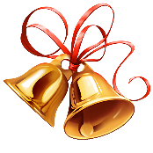

SUTTON HEATH PARISH COUNCIL WISH YOU ALL A VERY
HAPPY CHRISTMAS AND A HEALTHY AND HAPPY NEW YEAR

