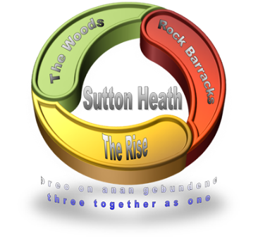
SUTTON HEATH PARISH COUNCIL
NEWSLETTER

Sutton Heath Parish Councillors:
Chair: Louise Chalklen 01394 766576
Vice Chair: Nick Ward 01394 461447
Councillors: Chris Hall 01394 461536

Issue No 28 December 2020

Roy Hirst 01394 460411
Rob Merriam 01394 461385
Adelle Betteridge 07814 388151
Elaine Prokopowycz 07493 873942
Sharon Hadley 01394 461140
Parish Clerk: Marion Merriam 07541 747679
Email: suttonheathclerk@yahoo.com
Website: http://www.suttonheath.onesuffolk.net/

As always, if you are in any particular need please contact the
Parish Clerk or one of the Councillors on the numbers above.
YOUR councillors are here for YOU!

HELLO:
We welcome two new Councillors to the parish council – Elaine Prokopowycz and Sharon Hadley. Both ladies have been living in this area for many years and are looking forward to getting further involved in the community in this new capacity.

GOODBYE:
As we welcomed our new Chair, Louise Chalklen, recently, that means of course that we had to say goodbye to our previous Chair, Colin Wearmouth. Colin has been heavily involved with the parish council since its inception 8 years ago and indeed was behind the success in introducing the No 71 bus service to Sutton Heath. Not only that – Colin was involved in many projects over the years, among them refurbishment of the Alan Crompton Hall, multi-use games area, the skate park, Dining in Sutton Heath, Sutton Heath Singers, New Year Eve Party, Remembrance Service, Christmas Carol Service and most recently the mobile post office. So we say ‘thank you’ Colin and wish you a happy and peaceful ‘retirement’!

BEING A GOOD NEIGHBOUR
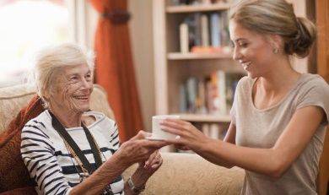
There are many Good Neighbour Schemes around, particularly in villages which can be classed as ‘rural’. This is something which the parish council are looking into so that people who may be lonely and vulnerable in our community and may need help, can be helped on an occasional or regular basis. In the meantime, being a ‘good neighbour’ is something we can all be, particularly as winter approaches and the current pandemic is still showing its ugly teeth, thus restricting visits by families in this Christmas period. So, if we all keep an eye out and check on the neighbours on either side of us, that is a good place to start.

USE IT - SO WE DON’T LOSE IT:
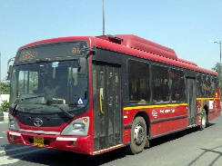
- The 71 Bus Service. If you haven’t used it yet … give it a go! It is hoped there will be tweaks to accommodate smooth linking up with the connection to Ipswich and return. Watch this space … Meantime, here is a note of the times from Rock Barracks to Woodbridge and return:

Mon-Fri
Rock Barracks dep 0733 0920 1120 1320 1450 1650
Woodbridge arr 0749 0936 1136 1336 1506 1706

Woodbridge dep 0905 1105 1305 1435 1635 1745
Rock Barracks arr 0917 1117 1317 1447 1647 1757

Sat
Rock Barracks dep 0920 1120 1320 1535 Adult fare - £2.90 return
Woodbridge arr 0936 1136 1336 1551 Under 19 - £2 return

Woodbridge dep 0905 1105 1305 1520 1735
Rock Barracks arr 0917 1117 1317 1532 1747

- The mobile Post Office comes to the Costcutter car park each Thursday 9-10am. Please use it. Saves a trip to Woodbridge … unless you’re going by bus!
- The mobile library visits the Costcutter car park from 12-12:20 once a month on a Wednesday. The last visit for this year will be on 9 December.

SUTTON HEATH LADIES GROUP
The ladies meet at 2pm on the second Monday of each month. If you fancy joining them - in a socially distanced way of course - then please give Eileen a ring on 421010.

JUST TO SAY:
- There is always up-to-date information on the Community Notice Board so do check it out.
- If the parish council could grant your wish, what would you like to see on the estate? Let the Parish Clerk or one of the Councillors know.
- The parish council are putting together an Emergency Plan so that in the event of any emergency they are well equipped to deal with it. If you can offer skills, resources, equipment or are willing to roll up your sleeves and help if the need arises, please do drop the Parish Clerk an email.

A message from Cllr James Mallinder, East Suffolk Council
“The ending of 2020 has been as difficult for most of us as the entire strange year.
Lockdowns, unsettling future, food shortage, isolation and a question of when will this all end?
However, here on the Peninsula there is an undercurrent of positive energy. Neighbours now know each other, communities have come together and volunteer groups have stepped up to assist those that need a helping hand.
As your ward member again and again I see acts of kindness and thoughtfulness. Contrary to concerns that society is fragmenting, Covid has brought society together.
We do care, and we want to care. A cup of tea with a neighbour in the garden or at a distance, once a rushed event is now treasured.
Nobody should suffer alone in these difficult times and I want to thank all you for checking on your neighbours and communities. A small gesture can make such a big difference.
Living in the middle of the AONB we have been cheered on our walks with our engagement with nature. Nature that carries on regardless. Time now given to the turning of the seasons and the change in landscape as we head into winter.
Once this is over and we look back at these times what will we learn?
Communities are alive and strong and we do care about the weaker members and those that need help.
Nature offers a reassurance nobody realised until we had time to stop and see.”

Minutes of the last Sutton Heath Parish Council meeting are on the community Notice Board, or can be viewed on the parish website

The Parish Council wish you all a very happy Christmas
and prosperous New Year

