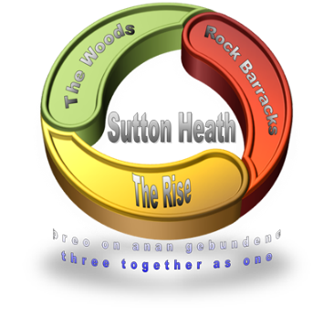
SUTTON HEATH PARISH COUNCIL
NEWSLETTER

Sutton Heath Parish Councillors:
Chair: Louise Chalklen 01394 766576
Vice Chair: Nick Ward 01394 461447
Councillors: Chris Hall 01394 461536

Issue No 29 January 2021

Roy Hirst 01394 460411
Rob Merriam 01394 461385
Adelle Betteridge 07814 388151
Elaine Prokopowycz 07493 873942
Sharon Hadley 01394 461140
Parish Clerk: Marion Merriam 07541 747679
Email: suttonheathclerk@yahoo.com
Website: http://www.suttonheath.onesuffolk.net/

As always, if anyone vulnerable is in any particular need re shopping, collecting prescriptions, posting letters – or getting to a centre to receive their Covid Vaccine, please contact the Parish Clerk or one of the Councillors on the numbers above and we will try to help. We are here for YOU!

HOME, BUT NOT ALONE
Freephone 0800 876 6926 ~ 9am-5pm ~ 7 days a week

GOODBYE:
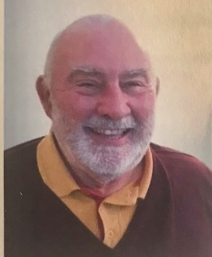
We were saddened recently to hear of the death of David Lowe. David was a Parish Priest for 50 years and supported the soldiers and families at Rock Barracks. During this time he performed Remembrance & Christmas services, as well as conducting weddings and funerals for the community at Sutton Heath. Whatever David did it was with overwhelming compassion and often with his magical smile and wicked sense of humour! David was a decorated member of the Reserve Forces and served with several units before becoming Chaplain to 23 Para Engr Regt in 2007. David and his wife Barbara lived on the Estate since 2008. They would have been married 50 years this year. Our heartfelt sympathy goes to Barbara and their 3 children and 6 grandchildren.

USE IT - SO WE DON’T LOSE IT:
- The 71 Bus Service. Have you used it yet? Here is a note of the times from Rock Barracks to Woodbridge and return:

Mon-Fri
Rock Barracks dep 0733 0920 1120 1320 1450 1650
Woodbridge arr 0749 0936 1136 1336 1506 1706

Woodbridge dep 0905 1105 1305 1435 1635 1745
Rock Barracks arr 0917 1117 1317 1447 1647 1757

Sat
Rock Barracks dep 0920 1120 1320 1535 Adult fare - £2.90 return
Woodbridge arr 0936 1136 1336 1551 Under 19 - £2 return

Woodbridge dep 0905 1105 1305 1520 1735
Rock Barracks arr 0917 1117 1317 1532 1747

- The mobile Post Office comes to the Costcutter car park each Thursday 9-10am. Please use it. Saves a trip to Woodbridge … unless you’re going by bus!
- The mobile library will resume in due course.

JUST TO SAY:
- THANK YOU once again to Jo Ragan and her team in our local Sutton Heath Community Store! Same store, different name … look out for new instore additions!
- There is always up-to-date information on the Community Notice Board so do check it out.
- Minutes of the last Parish Council meeting can also be found on the Community Notice Board and on the Sutton Heath Parish Council website above.
- East Suffolk Council will be distributing leaflets reminding us what – and what not – to put in our recycling bins. There has been a great deal of contamination recently – the main culprits being: bottles, tetra paks and nappies …!
- If you are aware of potholes on MOD land which need filling in or streetlights which have gone out please report these to sharron.mayhew997@mod.gov.uk (quoting the number which is on the back of the streetlight).
- On 21 January Norse suspended their bulky waste collection service. They ask that we either hold on to the bulky waste until the service resumes or make an appointment at the Foxhall Recycling Centre for items which can more be easily disposed of.

DID YOU KNOW?
- That there is a defibrillator on the Estate? It is located to the left of the main door to The Alan Crompton Hall.

JUST A THOUGHT:
- If you think someone on their own might be needing a bit of help, why not pop your contact details on a note through their door …

EVENTS COMMITTEE ~ Volunteers Wanted
At the recent Parish Council meeting it was agreed to re-form the Events Committee with representation from the civilian and military communities. Cllr Betteridge will be the parish council representative on the committee. DISH events etc would come under this too. If anyone is interested in joining this committee please let the Parish Clerk know.
CENSUS DAY : 21 March 2021
The next ‘once in a decade’ census is almost upon us. Households in Sutton Heath will soon be asked to take part in the nationwide survey of housing and the population. It has been carried out every decade since 1801, with the exception of 1941. Information from the digital-first census will help decide how services are planned and funded in our local area (in some areas this could mean things like doctors’ surgeries, housing or new bus routes).
Households will receive a letter with a unique access code in the post, allowing them to complete their questionnaire online. Paper questionnaires will be available on request.
More info is available on census.gov.uk

‘THE DIG’
Find out more about the history of the local area – Sutton Hoo to be precise! A new film entitled The Dig starring Ralph Fiennes is now available on Netflix.

A reminder that better days are coming …

