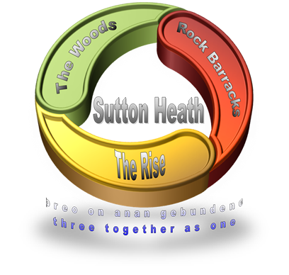
SUTTON HEATH PARISH COUNCIL
NEWSLETTER

Sutton Heath Parish Councillors:
Chair: Louise Chalklen 07846 474604
Vice Chair: Nick Ward 01394 461447
Councillors: Roy Hirst 01394 460411
Adelle Betteridge 07814 388151
Issue No 40
Nov/Dec 2022

Elaine Prokopowycz 07493 873942
Sharon Hadley 01394 461140
Matt Thomas 07926 611955
Parish Clerk: Marion Merriam 07541 747679

Email: suttonheathclerk@yahoo.com
Website: http://www.suttonheath.onesuffolk.net/
_________________________________________________
If you are in any need, please contact the Parish Clerk or one of the Councillors
HELP WITH DEBT & HOUSEHOLD EXPENSES to EASE THE SQUEEZE
- Suffolk Advice & Support Service Helpline (SASS): for financial advice, or support with access to food, you can call 0800 068 3131 between 9am – 5pm Monday to Friday. You can call them to get advice about debt, rent or mortgage arrears or one-off grants for things like white goods and fuel vouchers.
- Suffolk Infolink: this is a directory that lists a wide range of community services across Suffolk. It’s a great place to find organisations that can help if you need it. See infolink.suffolk.gov.uk and search for debt advice, foodbanks etc.
- For information, including practical support, funding and advice call 0333 016 2000 or visit
www.eastsuffolk.gov.uk/squeeze.
- Grants are available to help home owners and private tenants make their homes energy efficient and warmer. Call 03456 037 686 to find out more.
- Ease the Squeeze: From January, anyone needing a warm drink or food please email suttonheathevents@gmail.com or pop in to see Adelle who will let them have a £5 voucher for Poppies.

FOR YOUR INFO:
- Poppies Coffee Lounge ~ Barnsdale Centre – 9:15am-2pm, Mon-Thurs
- Rockies Resell Shop with Gifts & Crafts ~ Barnsdale Centre – 9:15am-2pm Mon-Thurs
- Community Store hours: Mon-Fri 7am-8pm; Saturday 8am-6pm; Sunday 8am-5pm
- Sutton Hoo: did you know that there is free entry for residents of Sutton Heath …? Show evidence of your address and they will let you in.
PLEASE USE IT - SO WE DON’T LOSE IT:
- The mobile Post Office – every Thursday 9-10am
- The mobile library – This will next be visiting on 10 January: 12noon - 12:20pm
- The Moving Plaice fish & chip van - Mondays 16:00-19:30. For orders call 07493 359269.
- The Burger Van: every Thursday from 4pm
- No 71 Bus Service to Woodbridge – See the timetable at the bus stop. If you have reached state retirement age and need help accessing a Senior Citizen’s bus pass please get in touch with Marion Merriam above.

UPCOMING EVENTS:
- December:
  - Community New Year’s Eve get-together/disco in the Crompton Hall. This is a free event 20:00-00:30 and strictly ticketed. Please collect tickets from Adelle BY 23rd December. Please bring your own drinks and nibbles. Donations on the evening to Blossom Appeal.

  - Bat & Chat – Table tennis. Weekly sessions start 2-4pm in Hollesley Village Hall in January if there is enough interest. Equipment is provided; tea and coffee available; bring soft soled shoes or trainers. All abilities welcome. Watch out for details of date etc.

ONGOING EVENTS:
Bingo Night: Resumes 12th January.
Yoga: Resumes 10th January.
Sutton Heath Ladies Group: meets on 9th January to discuss future activities. Please
phone Eileen on 421010 or Pauline on 420910 for information.

SANDLINGS PRIMARY SCHOOL
Hello, it’s Olivia, Polly and Charlie. We are part of the school council, and we would like to share with you all the different books our classes have been reading. Everyone in our school, children and teachers, all agree that reading is a wonderful thing!
In Early years (Hedgehogs Class), children have been reading a story called “One Snowy Night” by Nick Butterworth. From what they have told us Percy the park keeper has had to help all the animals: a hedgehog, ducks, mice and a badger. They have really enjoyed the story.
In the Years 1 /2 (Owls class), they have been reading “The Queen’s Nose” By Dick King-Smith. The characters are Harmony, Melody and Uncle Ginger. Harmony is given is a magic coin, which grants her wishes when she rubs the queen’s nose! It makes all her dreams come true in unpredictable ways.
In Years 3 / 4 (Foxes Class), they have been reading “Grimwood” by Nadia Shireen. It’s about two foxes, Ted and Nancy, who move to Grimwood from the city for a talent show. There is also an evil cat called Princess Buttons. From what they have told us, she is a very evil cat. They also told us about Eric Dynamite who keeps popping up with lots of different ideas. They said it is a really funny book.
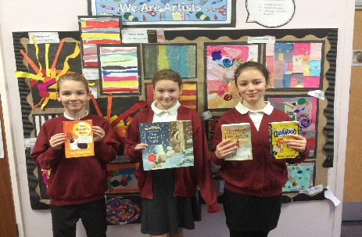
In Years 5/ 6 (Nightjars class), we have been reading “Letters from the Lighthouse” by Emma Carroll. It’s about two children, Olive and Cliff, who get evacuated from London to a fictional place called Budmouth Point. They go to school, experience a German plane crash and get to live in a lighthouse. However, Olive had different ideas: to find her sister Sukie who had mysteriously disappeared after an air raid. We love this book and have used it as inspiration for our own writing.
Don’t forget you can follow us on Facebook https://www.facebook.com/SandlingsPrimarySchool/ and Twitter @SandlingsP
Best wishes, Miss Toal and the Sandlings Team

SSAFA (Soldiers’, Sailors’ & Airmen’s Families Association)
- Community Coffee Morning. This will be held on Tuesday 17th January 2023 at 10am in the Crompton Hall. Everyone is welcome.

The “Blossom Appeal for Ipswich Hospital” total so far is … £2,187.35

The next Parish Council Meeting will be held on Monday 9th January 2023. The meeting will be held at 7pm in the Barnsdale Centre. All welcome.

WISHING YOU A VERY HAPPY CHRISTMAS, FROM SUTTON HEATH PARISH COUNCIL

