SUTTON HEATH PARISH COUNCIL
NEWSLETTER

Sutton Heath Parish Councillors:
Chair: Louise Chalklen 07846 474604
Vice Chair: Nick Ward 01394 461447
Councillors: Adelle Betteridge 07814 388151
Elaine Prokopowycz 07493 873942
Sharon Hadley 01394 461140
Issue No 41
Jan/Feb 2023

Matt Thomas 07926 611955
Parish Clerk: Marion Merriam 07541 747679

Email: suttonheathclerk@yahoo.com Website: http://www.suttonheath.onesuffolk.net/
_____________________________________________________
If you are in need during this cold weather, please contact one of the above
EASE THE SQUEEZE
- Ease the Squeeze: From January, anyone needing a warm drink or food please email suttonheathevents@gmail.com or pop in to see Adelle who will let them have a £5 voucher for Poppies.

FOR YOUR INFO:
- Poppies Coffee Lounge ~ Barnsdale Centre – 9:15am-2pm, Mon-Thurs
- Rockies Resell Shop with Gifts & Crafts ~ Barnsdale Centre – 9:15am-2pm Mon-Thurs
- Community Store hours: Mon-Fri 7am-8pm; Saturday 8am-6pm; Sunday 8am-5pm
- Sutton Hoo: did you know that there is free entry for residents of Sutton Heath …? Show evidence of your address and they will let you in.
PLEASE USE IT - SO WE DON’T LOSE IT:
- The mobile Post Office – every Thursday 9-10am
- The mobile library – 12noon - 12:20pm. Dates for 2023: 1 Feb; 1 Mar; 29 Mar; 26 Apr; 24 May
21 Jun; 19 July; 16 Aug; 13 Sept; 11 Oct; 8 Nov; 6 Dec
- The Moving Plaice fish & chip van - Mondays 16:00-19:30. For orders call 07493 359269.
- The Burger Van: every Thursday from 4pm
- No 71 Bus Service to Woodbridge – See the timetable at the bus stop.

UPCOMING EVENTS:
- Friday 10 February: Community Quiz, 7pm at Crompton Hall; bring your own drinks and snacks. Book tickets (£10 each) and supper choices (jumbo sausage & chips / fish & chips / vegan pasta bake) via suttonheathevents@gmail.com or Adelle 07814 388151 at Barnsdale Centre.
- Friday 31 March: Beats Bingo! 5 games of music bingo for £10 – with cash prizes. Further details to follow nearer the time so watch this space …!

ONGOING EVENTS:
Bingo Night: Every second Thursday; Room 8 round the side of Nursery. 7.15pm for 7.30pm start.

Sutton Heath Ladies Group: this lovely group of ladies meet at 2pm on the second Monday of each month. Please phone Eileen on 421010 or Pauline on 420910 for more information.
Sutton Heath Singers: Every Tuesday 7:30-9pm at Sandlings Pre-school Community Room. No experience necessary. £3 each week or pay for 6 weeks in advance.
Yoga: Room 9, Childcare Centre – Tuesdays 10:00-11:00 (beginners & advanced); Thursdays 18:30-19:30 (more intense stretching/moving – beginners welcome). £30 for 6 sessions. Contact Anne 07471 474156 or annedeane.yoga@gmail.com

SPECS RECYCLING
Give the gift of recycling your unwanted spectacles and sunglasses via Lions Recycle for Sight who provide glasses and sunglasses to people in need overseas. A swing bin is in the Barnsdale Centre corridor by Poppies, or alternatively you can leave any unwanted specs at 12 Chequer Field.
SANDLINGS PRIMARY SCHOOL
Hello, its Olivia, Polly and Charlie. Happy New Year! For this newsletter we have been thinking about the importance of performance!
We ended last term watching the KS1 and Reception Christmas play -“Little Robin Red Vest”. During the play the robin gave away each of his coloured vests to all the creatures and people who were cold; fairies, snowmen, toy soldiers and eventually baby Jesus. Consequently, little robin had no more vests and became very cold, but on Christmas Eve Santa gave the robin a little red vest to keep warm for ever! The play not only reminded us all of the Christmas story, but the importance of kindness.
In December our school choir visited Glebe house, in Hollesley, to sing Christmas carols to all of the residents. Songs such as “Jingle Bells”, “12 Days of Christmas” and “On a Starry Night” brought joy to the residents who gave a thunderous applause at the end. We were so happy to bring smiles to their faces.
In January the whole school went to The New Wolsey Theatre to see the rock and roll pantomime “Goldilocks and Three Bears”. It was inspirational for us to see talented actors, singers and musicians as well as fantastic scenery, props, costumes and lighting. For many of our school it was their first time in a theatre and to see the wonderful tradition of British Pantomime. We saw how the well the cast engaged all of the audience in traditional pantomime banter “he’s behind you!” “Oh no you won’t “oh yes we will” cried the audience old and young. The importance of performing and watching performances is so important to us all; inspiring and teaching us, making us laugh and bringing communities together.
You can follow us on Facebook https://www.facebook.com/SandlingsPrimarySchool/ & Twitter @SandlingsP
TIME TO GET WALKING: www.walkinginengland.co.uk john@walkinginengland.co.uk
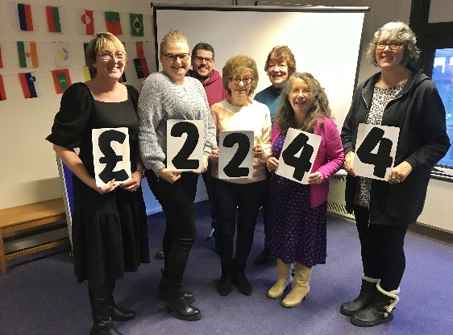
Walking in Suffolk https://www.walkinginengland.co.uk/suffolk has loads of walks to download and print free. It also has books of walks, details of all the walking groups in the county and much more. Whether you want to walk on your own or with a group all the information is there in one place. John Harris said ‘There is so much walking information on the web but it is difficult to find. Walking in Suffolk has brought it together in one place. With walks from half a mile to twelve miles plus long, and a note of suitability for pushchairs and wheelchairs, everyone can find a walk to enjoy.

BLOSSOM APPEAL
On Friday 27 January a cheque was handed over to a representative of Colchester & Ipswich Hospitals Charity from Sutton Heath Parish Council in the sum of £2,244 towards the Blossom Appeal which was our Charity of the Year 2022. A huge thank you to our generous community for supporting the various community events enabling this to happen.

Introducing our Charity of the Year 2023: SPCF (Suffolk Parent Carer Forum)
This is a local charity representing “the voices of families with children and young people with special / additional needs or disabilities”. See their website for further information: www.suffolkpcf.co.uk

The next Parish Council meeting will be held on Monday 13th March 2023. The meeting will be held at 7pm in the Barnsdale Centre. All are welcome.

