Issue 42 – March April 2023
Sutton Heath Parish Council
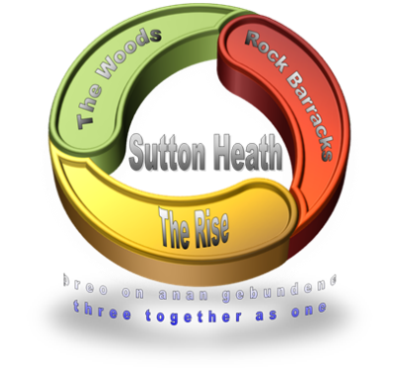

Upcoming Events

May 15
Parish Council Meeting – 19:00

May 17
Curry and Quiz Night – 19:00

July 22
Community Fete School Fete 12 – 15:00
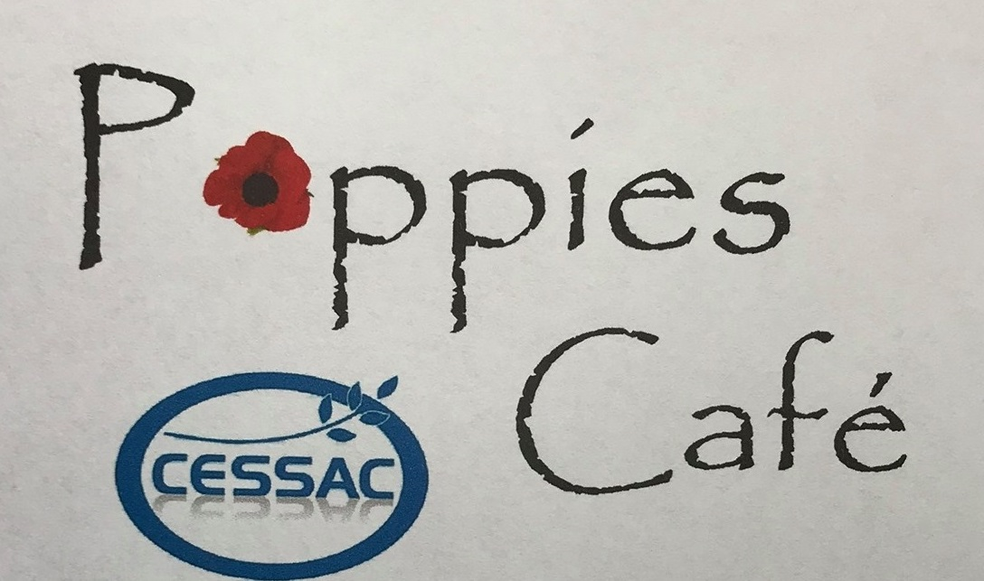

Pop in for breakfast, a cuppa, cake or lunch prepared locally.

Mon – Thurs 9:15 – 14:00
Fri – Sun Closed
Mondays 4 – 7pm
Community Store Car Park
For orders/delivery please call 07493 359369
Special dietary requirements catered for

Barnsdale Community Centre
www.suttonheath.onesuffolk.net
E: suttonheathclerk@yahoo.com

Meet your Parish Council
Chair:  Vice Chair:  Councillors:  Parish Clerk: | Louise Chalklen  Nick Ward  Adelle Betteridge  Matt Thomas  Elaine Prokopowycz  Sharon Hadley  Marion Merriam  Victoria Daly | 07846 474604  01394 461447  07814 388151  07926 611955  07493 873942  01394 461140  07444 641346  07541 747679

Parish Council Elections
Congratulations to the Councillors who have been appointed their seats for another four year term. Thank you to Councilor Roy Hirst who has decided not to run for nomination this term and Congratulations to Marion Merriam, who, after serving the council as the Parish Clerk the last four years has decided to continue to serve the community as a Parish Councilor.
There are currently two vacant seats available on the council. If you are interested in becoming a council member or would like to find out more information, please contact the Parish Clerk via email at suttonheathclerk@yahoo.com.

Passionate for Pétanque?
The Events Committee are looking for feedback from the community to see if there is interest in building a Pétanque pitch near the memorial gardens. Pétanque, similar to Boules, is played with smaller metal balls that are thrown. Please contact Adelle Betteridge to have your say.

More Important News
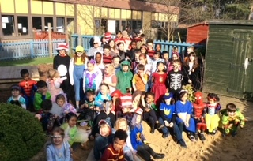

In the Community

Crochet/Knit and Natter:
Making Remembrance poppies for the Rock Gardens. No experience necessary.
1st Wednesday of the Month 1-3pm

Bingo
Every 2nd Thursday, Room 8 round the side of nursery

7:15pm for 7:30pm start.

Yoga
£30 for 6 sessions. Contact Anne on 07471 474156

Tuesdays 10:00 - 11:00
Thursdays 18:30 – 19:30

Sutton Heath Singers
Sandlings pre-school community room.
£3 per session payable on a 6 week basis.

Tuesdays 19:30 – 21:00

Sutton Heath Ladies Group
2nd Monday of each month

Contact Eileen on 01394 421010 or Pauline on 01394 420910

Mobile Post Office
Every Thursday 9:00 – 10:00

Mobile Library
4th Wednesday of each month

12:00 -12:30

The Wandering Grill
Every Thursday from 16:00

Sandlings Primary School
Hello, it’s Olivia, Polly and Charlie, and in this article we will be talking about two different celebrations that we have all been involved in this term; World Book Day and our participation in the Celebration 2023 concerts at Snape Maltings.
On the 1st and 2nd of March, we celebrated World Book Day. As part of our celebrations the whole school visited “Woodbridge Books” to spend our World Book Day vouchers. We travelled in our school mini-bus throughout the morning, ferrying groups to the book shop. We were also able to buy some books for the school library; It was hard to choose as there were so many great books there!
On the 2nd of March, we dressed up as our favourite book characters. All the children dressed up using wacky props, from wooden hands to a giant-sized inflatable alien costume!
In the afternoon we made dioramas based on our class novels. In the Year 5/6 class, we made our dioramas based on: Letters from the Lighthouse by Emma Carroll, Percy Jackson and the Lightning Thief by Rick Riordan and Tuesday. We had fun making them! At the end of the day all our parents joined us for the Reading Café.
We performed at Snape Maltings on the 8th of March. We sang a personalised version of the song ‘We are young’ by Fun and also performed a Samba. The finale song was called “Me” and it was composed by Charlotte Harding. We did a tech rehearsal as well as a workshop with Charlotte. Our performance was first so we were very nervous! However, once we were on stage, all our worries went away and we really enjoyed the performance.
Hope you enjoyed this article!

New Toddler Park on Ipswich Avenue
The children’s park on Ipswich Avenue had its grand reopening! The weather was wet however families braved the rain with their little ones to be the first to have a play. The park features new toddler friendly equipment including swings, seesaws, roundabouts, rain makers and chimes.

Free First Aid Course
Would you know what to do if your friend, family member or neighbor had a medical emergency? Initial treatment can be critical, so having basic first aid training can help save a life.
Therefore, your Parish Council have arranged a FREE one day First Aid Training Course.
To register your interest please provide your name, address and telephone number to: suttonheathclerk@yahoo.com or text 07846 474604

