.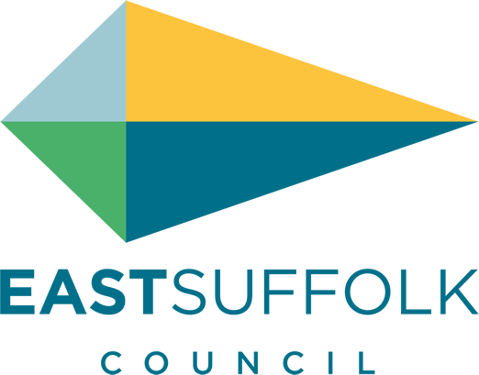

March 2021

Welcome to my monthly newsletter

Government roadmap out of restrictions
The announcement by the Prime Minister about the easing of restrictions is the news we have all been waiting for and the clearest indication yet that the vaccination programme is our best route out of the pandemic.
I would encourage everyone who is offered the vaccine to take it, and for those waiting hopefully to be patient as the first dose is administered to priority groups. However, we are by no means out of the woods yet and it is vitally important that we follow the guidelines that will remain in place for some time yet.
It feels like we are really close to a return to normal but, even as vaccines are delivered, this won’t happen if we don’t continue to obey social distancing, mask wearing rules and of course, washing our hands.
We must be led by the data rather than dates and if we want the situation to improve.
Communities and supporting residents
I am delighted to report that all of the East Bags are now been packed and distribution. I am really pleased through proactive parish councils on the Peninsula and the Good neighbours Schemes I have distributed 60 bags to our lonely elderly residents .
In addition to the 2,132 19-70 year olds who were added to the Clinically Extremely Vulnerable list in early February a further 3,817 over 70 year olds have now been added. This brings the total number of people in East Suffolk who are shielding to 20,164. The Communities Team have completed around half of the contacts to the first group (emails or calls) and will be starting the calls to the recent additions at the end of next week. I have volunteered to call a number of residents to check they are ok.
The Home But Not Alone phone line continues to be active
First week of January the Communities Team called all those who needed support during lockdown 2. This includes anyone who was either referred to Home But Not Alone or Suffolk Advice and Support Service, are lonely or isolated, were helped to register with the National Shielding Support Service or had other needs identified. And we continue to make sure resources are focused on those that need help the most.
The Covid-19 Hardship Fund has been topped up so if any local groups would benefit from additional funding during the third lockdown, please let me know.
As always anybody can speak to me in confidence, and if I cannot help I will signpost to other organisations .
Environmental Services
Environmental Protection
The emergence of the more contagious variant of covid will affect the activities of the Environmental Protection team. As a general rule the team will not be undertaking visits to premises for any purpose. This will have an effect on proactive inspections and reactive visits for all purposes including water sampling, nuisance monitoring visits, licence and permit inspections and many other site-visits involving entry to premises. They will be exploring ways of undertaking these activities remotely.
They key is evidence , so please take photographs when reporting if possible. Please copy me on any initial communication so I can monitor the pattern across the district and follow up when necessary .
Issues to be sent to : environmental.protection@eastsuffolk.gov.uk
Palm Oil has been appearing on our coastline although not harmful , it can cause problems if swallowed . In particular this is a concern for dog owners and I remind all dog owners to be responsible and not only control their dogs in public places , in particular beaches , but to clear up after their dog . Dog mess in particular is becoming quite a problem on our footpaths .
As we move into spring bird scarers are causing concerns for a number of residents so I am asking if any issues are logged through Environmental protection and perhaps the Parish council can pick the issue up and communicate concerns to local landowners .
A helpful leaflet produced by the NFU can be found here :
https://www.nfuonline.com/assets/4662

Operational update
We thank residents for their understanding of our suspension of bin collections due to bad weather .
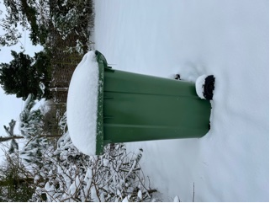
All collection dates are back as per our normal schedule .
As we slowly come out of lock down and the weather improves our visitors will be increasing. Great for our local businesses but can be challenging in our control of litter . We have contacted our seaside resorts and market towns and will be increasing the number of bins, frequency of collections and in some cases portaloos .
Bawdsey will receive extra bins and increase in frequency of emptying .
However Shingle street are doing the opposite and have removed bins from one of their carparks on the assumption if no bin then visitors take their rubbish home - we watch this experiment with interest .

Pardon the Weeds
As spring starts to take hold across East Suffolk I will be launching Pardon the Weeds we are Feeding the Bees campaign later this month .
This year we will have 100 + sites and I have reduced the use of glyphosate by over 45 pct
Its important we do as much as we can to protect our local ecology and support our wildlife esp our insects .

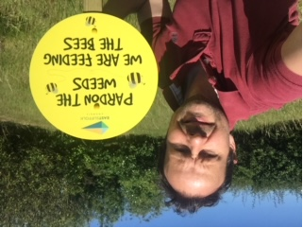

Grants, funding and business matters
In total, since the launch of a plethora of new business grants in November 2020, ESC has made over 12,300 payments totalling £24.8m to businesses struggling due to enforced closure or severe restrictions on trading. Since the beginning of the pandemic the Council has allocated over £90m of grants. A further lump sum payment totalling £792k was made to 280 businesses who qualify for the Additional Restrictions Grant mirroring the Closed Business Lockdown Payment which recipients of the Local Restrictions Support Grant received in January.
A reminder that in order to simplify the process for businesses there is now a streamlined application process which can be found on ESC’s Covid business support webpage COVID-19: business grant funding » East Suffolk Council. Once completed ESC will determine which grant businesses are eligible for and make the appropriate payment. In a further bid to simplify and make the process more efficient businesses who have successfully applied for previous Covid grants will receive automatic payments from the current grant schemes.

Customer Services
Our service remains unaffected as measures are already in place with a remote call centre, maintaining staff resilience to reduce absences and alternative channels of access for customers. We are encouraging people to access our services and information online where possible. Public access remains closed; however emergency access / support measures are in place if required.

And From the chancellors announcement I am pleased that nationally East Suffolk is being recognised - with Lowestoft being granted £24.9m in funding as part of the Government’s Towns Fund.
And confirmation of the development of Freeport East, which will be centred on the Port of Felixstowe and Harwich International Port.

I really do feel 2021 already is giving us hope that East Suffolk will emerge out of the lock down strong and ready to prioritize the environment along with good employment prospects and a strong economy .

James Mallinder
Deben Ward
Environment Portfolio holder

