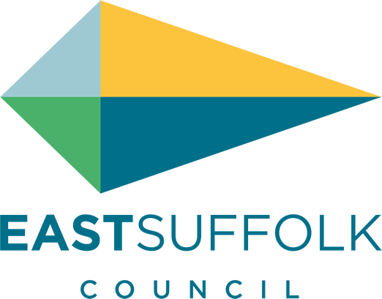

January 2020

Welcome to my monthly newsletter

Community projects receive funding boost
Following a successful application to East Suffolk Council’s Enabling Communities ‘Exemplar Grant Programme’ earlier this year, 17 community projects have been chosen to each receive a share of £147,378 to help deliver projects and activities which will benefit East Suffolk residents.
The selected projects include the refurbishment of local village halls and play areas, the construction of a Heritage Hut, theatre workshops to help disadvantaged groups engage with the arts and the delivery of a programme to tackling eating disorders in local schools.
Since 2016, 68 community projects have benefitted from the Exemplar Grant Programme, receiving funding totalling £544,014.36. £160,000 was allocated for the 2019/2020 programme from the New Homes Bonus.

I am pleased to confirm here on the Deben ward we received three of these grants
- Woodbridge Rugby club – based in Bromeswell
- Hollesley Village Hall
- Hollesley Parish Council

Whilst applications for this round of the programme are now closed, local groups and organisations can still apply for funding to support their activities via the Council’s ‘Enabling Community Budgets’ at www.eastsuffolk.gov.uk/enabling-communities-budgets.

Report recognises Council’s climate change efforts
Members of East Suffolk Council’s new Environment Task Group, set up in response to the Council’s declaration of a climate emergency, met for the first time earlier in November to review a report from Groundwork Suffolk following an independent review of the Council’s performance on reducing its carbon emissions.
The report recognises the steps the Council has already taken to reduce carbon emissions by almost 23% over the last three years, including moving to its new energy efficient buildings in Lowestoft, which benefits from solar PV and Melton, which is heated by air-sourced heat pumps and installing solar PV at the recently refurbished Deben Leisure Centre and Leiston Leisure Centre.
The report then goes on to identify areas that the Council will need to focus on to achieve its ambitious target of becoming carbon neutral by 2030.
Small changes can make a big difference and the Council recently published a guide to help residents and businesses take steps to reduce their carbon emissions. To view the guide, go to www.eastsuffolk.gov.uk/environment/climate-change/
Free audits are also available for businesses in East Suffolk from Business Energy Efficiency Anglia to help them become more energy efficient. For more information, go to www.eastsuffolkmeansbusiness.co.uk/business-support/resources/business-energy-efficiency/.

Sale of empty properties will fund new housing
The first of three Lowestoft properties, which have stood empty for several years due to low demand from tenants has been put up for sale. The sale of these properties will remove the issues associated with long-term empty properties, such as anti-social behaviour, and encourage new families to the area. The decision, which was supported by the local community, was taken by Cabinet in October and proceeds will be reinvested into more suitable affordable housing in the town.
The Council currently owns five 6-bedroomed properties in Cleveland Road, four of which are unoccupied. Due to low demand for homes of this size from families on the housing register, some of these properties have been empty for several years. This has resulted in their deterioration, as well as encouraging anti-social behaviour, such as vandalism, fly-tipping and squatting.
Previous options considered for these properties included conversion into flats however Cleveland Road is within the ‘flat saturation zone’ so this was not a feasible option. Another proposal was for conversion into a supported housing scheme however this was declined due to planning policy.

Celebrating East Suffolk’s best building design
The winners of East Suffolk Council’s ‘Quality of Place Awards’ were revealed at an awards ceremony on Wednesday 20 November, held at East Suffolk House in Melton.
The awards recognise the efforts of people across the district to enhance the quality of the environment, by creating high-quality designs in both the built and natural environment and helping to conserve historic buildings.
Nominations are judged on quality of design and detailing, quality of workmanship, use of materials and sustainability.

Sutton Hoo being a well deserved winner .

To see the full list of winners, go to www.eastsuffolk.gov.uk/news/celebrating-east-suffolks-best -building-design/

World cycling championship coming to East Suffolk
Last month, the Union Cycliste Internationale (UCI) announced that the 2021 and 2022 event will be held at Trinity Park in East Suffolk. Ahead of this year’s World Championships in Belgium, which begin on 29 November, 2021 and 2022 World Championship organiser Steve Grimwood, together with partners from East Suffolk Council and the Eastern Cyclo-Cross Association have announced the events will take place on 5 and 6 December 2021 and 4 and 5 December 2022.
Suffolk has a strong track record of delivering major cyclo-cross events, including three national championships, an edition of the European Championships and numerous events registered on the UCI International Cyclo-Cross calendar. Most recently, the venue played host to round five of the 2018/19 HSBC UK Cyclo-Cross National Trophy Series.

And finally I wish you all a very happy New Year .

James Mallinder
Deben Ward
Environment Portfolio holder

