July 2020

Welcome to my monthly newsletter

Remember STAY AT HOME, PROTECT OUR NHS, SAVE LIVES
Latest national information on coronavirus: https://www.gov.uk/coronavirus
NHS advice: https://www.nhs.uk/conditions/coronavirus-covid-19/
The refreshed COVID-19 pages present a range of information that you and your communities may find helpful. https://www.eastsuffolk.gov.uk/covid-19
Communities and supporting residents
The total number of referrals dealt with through ‘Home But Not Alone’ up to 28 June was 1,721. Just over 1,200 of these referrals were from the Lowestoft and Northern Parishes Community Partnership area.
There are currently 7,043 East Suffolk people on the shielding list because they are extremely vulnerable. Government support for those shielding is ‘paused’ from 31st July meaning that people will no longer receive a free food box or prescription delivery but they will retain their access to priority shopping slots at local supermarkets. The Communities Team is therefore working with those referrals to try to ensure they have a sustainable source of support from August onwards.

We now have more than 175 residents in the Lowestoft area who are receiving a weekly phone befriending phone call from Councillors, officers or volunteers. We have had so much positive feedback with one resident recently describing it as her ‘lifeline’. We are now looking at ways to develop this into an ongoing source of support. Thanks to all the Councillors who have been a befriender!

We took delivery of our 25 ‘Grandpad’ tablet computers this week and the Communities Officers are distribution them to the recipients who have been chosen because they are isolated, don’t have access to wifi or a computer/tablet and would benefit from simplified technology. Our first delivery was to a Lowestoft resident – Austin Reddy – who was delighted. We hope that people will use their Grandpads to stay in touch with friends and family but also to access food and prescriptions and for health consultations.
Grants, funding and business matters
Response
Both business grants schemes are still open for applications and as of 26 June £61.4m had been paid out to over 5,300 businesses across ES. We have now received a large number of thank you emails via MPs. Cllrs and from businesses themselves demonstrating how important these grants have been in sustaining business during this incredibly challenging time and retaining employment. Furthermore, we have built up good working relationships, intelligence which has supported more targeted business support.

The ED team, with strong support from EH and Assets is continuing to roll out the Reopening High Streets Safely Fund. We have now facilitated temporary changes to highways in Beccles, Woodbridge and Felixstowe and are also about to deliver signage and other items to support social distancing to Town Councils. The limitations of the ERDF fund have meant that ESC is now directly funding some of the highways changes in order to expedite matters and ensure high streets are safe ahead of the further relaxation of lockdown rules this weekend.

Recovery
The regional ‘Restart Plan’ was launched this week and this targets short-term measures to support the economic recovery. ESC have been instrumental in developing this plan and will continue to be so during its delivery. We also continue to work on adapting the Suffolk Growth Framework and ES Economic Delivery Plan to ensure our interventions support the post-Covid economic recovery phase.

Initiatives such as the Lowestoft Town Investment Plan, Masterplan, Felixstowe BID development, town centre revitalisation programme and Smart Towns Initiative are all part of our continued investment in the East Suffolk economy and will form a major part of the recovery phase. Combined with continued investment through schemes such as the Third Crossing, Sizewell C, offshore energy, potential Freeport status provide solid grounds for the local economy’s ability to bounce back.

Environmental Health
The Food & Safety Team have written to over 1000 businesses in the hospitality sector in advance of the easing of lockdown requirements for pubs, restaurants, cafes etc from 4 July. The letter provides links to government guidance on Covid-19 secure measures to be taken by businesses in the hospitality sector, information on outdoor seating and a checklist for businesses to help them prepare for opening. The letter, drafted with input from the Food & Safety and Licensing Teams, has been followed up by officers with some spot check calls to provide further advice and confirm that control measures are being implemented. Environmental Health staff will be on standby over the weekend to answer any queries or complaints including any noise issues.
The Suffolk Covid-19 Outbreak Control Plan has been approved and submitted to government and Stuart Keeble, The Director of Public Health, has been involved in promoting the local Test & Trace arrangements with the media. A Suffolk Covid-19 Coordinating Centre has been established to coordinate local outbreak control activity. A Dashboard and traffic light system is being developed to help the Suffolk C-19 Health Protection Board monitor local cases and provide an early warning of rising numbers of confirmed cases. At present the number of new cases remains low.

Operational updates

Dealing with increased littering
We have seen issues with increased littering over recent weeks. We are addressing this by putting in additional bins and collections and have designed targeted posters for particular locations encouraging people to put litter in the bin – or take it home.

Play areas
East Suffolk Council play areas are reopening on the 4th July. A risk assessment has been carried out, and government advice on safe use will be in place in all locations. They key messages are that people need to keep their distance, and that children need to clean their hands before and after use.
Grounds maintenance:
Normal grass cutting has resumed in many areas now. Some areas that have not been cut to offer the potential to create wildlife buffers – particularly in larger areas of open space, and we are writing to town and parish councils to set out our approach to grass cutting, including maximising the opportunity to retain some areas that have become havens for wildflowers and invertebrates. Our New Conservation areas , with the banner headline of ‘ pardon the weeds we are feeding the bees ‘

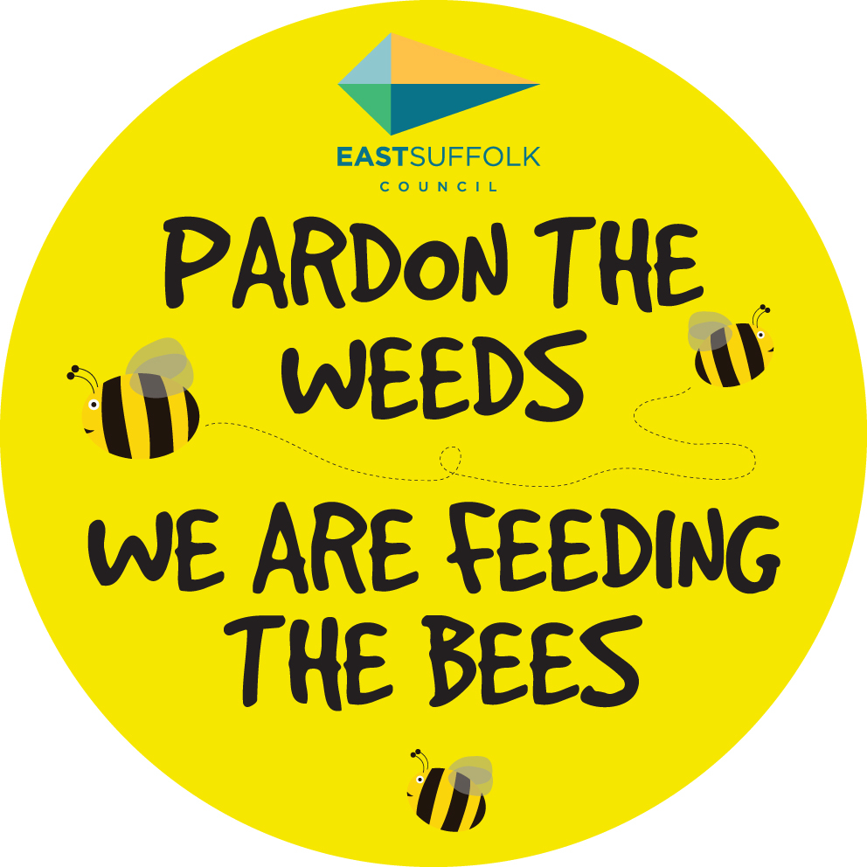

Misc :
Early June I met with the manager of the Teapot Project in Woodbridge . Not a food bank but an organisation helping those that might not be eligible for benefits but just need a helping hand . I have volunteered to help and East Suffolk have been able to support this project through various grants .

In response to the Planning Inspectors decision on allowing Sizewell DCO East Suffolk’s official statement can be found here :
https://www.suffolk.gov.uk/council-and-democracy/council-news/show/joint-statement-from-sizewell-c-joint-local-authorities-group

Across my ward we have suffered negative impacts from tourists. I have worked with Shingle Street and Bawdsey PC in particular to make sure sufficient bins are in place and have increased the frequency of collections from Monday and Friday to now include Wednesday .

James Mallinder
Deben Ward
Environment Portfolio holder

