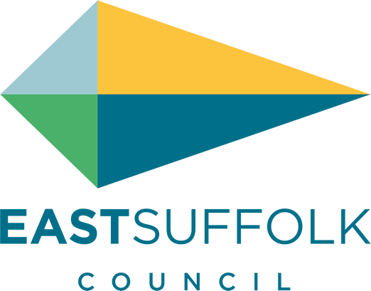

May 2020

Welcome to my monthly newsletter

Remember STAY AT HOME, PROTECT OUR NHS, SAVE LIVES
Latest national information on coronavirus: https://www.gov.uk/coronavirus
NHS advice: https://www.nhs.uk/conditions/coronavirus-covid-19/

The refreshed COVID-19 pages present a range of information that you and your communities may find helpful. https://www.eastsuffolk.gov.uk/covid-19

Communities and supporting residents
The Communities Team has now dealt with more than 1000 referrals through the Home But Not Alone service but the numbers last week (Week 5) were the lowest yet with a total of 175 referrals. 106 people asked for help with food, 53 with access to prescriptions and 7 with isolation and loneliness last week.
The Home But Not Alone postcard is being delivered to every house in Suffolk this week with the aim of ensuring that every single person who needs help and support has been reached either by their local community group or through Home But Not Alone.
We are going some more targeted work next week to contact people who have all three types of vulnerability – clinical, social and financial to ensure that they have all the support that they need as the Covid-19 crisis is likely to have the biggest impact on this group. We are also working with our new regional MHCLG shielding co-ordinator to try to address some of the challenges that remain around the national shielding service.
The Council has now supported 44 projects through the Hardship Fund totalling over £63,000 – including Good Neighbour Schemes, Town and Parish Councils and small community groups.
Grants, funding and business matters
Business Grants:
The ED team, with great support from other teams across the Council (Elections, Democratic Services and Building Control) have completed the c2,000 calls to eligible businesses that had not yet applied for their grant funding. This has been a huge undertaking, a great example of teamwork across the Council and has been completed in just over a week. Furthermore, it has resulted in a large number of East Suffolk businesses receiving badly needed grant funding.
The ED team are now collating a list of businesses we anticipate will be eligible for the extended/ discretionary grant scheme ahead of detailed govt guidance being supplied before the end of the week. This extended scheme should be of great assistance to a large number of East Suffolk companies especially those occupying serviced/ shared office space who were previously ineligible because they paid business rates as part of their rent. Serviced/ shared office space of this nature includes Innovation Martlesham based at Adastral Park, Orbis Energy in Lowestoft, the two NWES sites in Leiston and Lowestoft and Framlingham Technology Centre.
Economic Recovery:
The Suffolk wide group of Councils, Suffolk Chamber and the LEP continue to develop the economic recovery plan for the county. This will involve measures aimed to support the short, medium and long-term phase of the recovery. The ESC ED team continues to take a prominent role in this work with a particular focus on the impacts and support Suffolk’s key economic sectors such as Tourism, Energy, ICT, Ports & Logistics and Agriculture face.
A survey of grant recipients was launched this week by Councils across Suffolk. The aim is to understand how the grant is supporting businesses and more importantly what further support measures they believe they will be needed in the future. A survey of businesses in the visitor economy sector, co-ordinated by Visit East Anglia, was also completed last week and we are now analysing the East Suffolk data to understand the current state of this sector and its longer term prospects.
Both these surveys will provide a critical evidence base for the formation of an effective economic recovery plan
Operational updates
Resumption of garden waste collections:
Council took the decision to re-start the garden waste service from 25th May Rounds are being re-programmed to accommodate collections over six days instead of five (so this will mean that collections will take place on a Saturday). The reason for this is to ensure that we can re-organise the arrangement of crews so that there are no more than two members of staff in a vehicle at any one time, in line with social distancing requirements.
Social distancing in the workplace:
Work is currently being undertaken both within our own offices and through our partners, to understand how a relaxation of lockdown rules could lead to a change in working arrangements. This could include allowing public access, where it is safe to do so, and the council re-establishing a point of presence in key offices across the district. Any new arrangements need to prioritise the safety of employees and the public, so we will be reviewing emerging government guidance and ensuring that any plans that we produce are compliant with the latest scientific advice.
Housing
It was announced on 2nd April 2020 that Dame Louise Casey will spearhead a specialist taskforce to lead the next phase of the government’s support for rough sleepers during the pandemic. A team of experts will be providing advice to Councils on plans to support rough sleepers into long-term accommodation after lockdown is lifted, ensuring as few people as possible return to life on the streets.
It is yet to be made clear how this will be delivered as lockdown measures are reviewed, however it is expected that this initiative will support Local Authorities to continue with all the positive work done so far so that we can continue to provide not only housing assistance but work with partners to ensure that physical and mental health support is in place now and in the future.
Environmental Health
Environmental Protection:
We have been monitoring fly-tipping complaints closely and the number of incidents has been generally consistent with previous years although we have seen a sharp increase in fly-tipping reports in the last week or so. The data shows a predominance of household waste of varying descriptions. The Environmental Protection team will continue to monitor these trends and take appropriate enforcement action to deal with incidents as they arise.
We have had our second public health funeral enquiry since the pandemic began. Although neither of these deaths have been related to COVID-19, the team have had to enter the care home of the resident who died to collect their personal items which may help in the search for next of kin.
Planning
The Planning and Building Control team have issued their latest monthly newsletter, providing a comprehensive round up of the team’s activities in relation to the pandemic. https://www.eastsuffolk.gov.uk/assets/Planning/Planning-and-Building-Control-Newsletter/19-Covid-Planning-Newsletter-May20.pdf
In other news…
For the first time ever, East Suffolk Council’s Cabinet meeting was broadcast live on YouTube this week. The meeting itself took place remotely, with all participating councillors joining by video link.
I spoke twice about the importance of the environment in our decision process .
You can view the meeting here : www.eastsuffolk.gov.uk/youtube

James Mallinder
Deben Ward
Environment Portfolio holder

