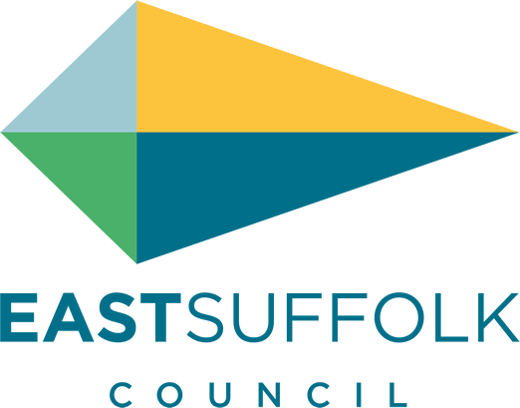

November 2020

Welcome to my monthly newsletter

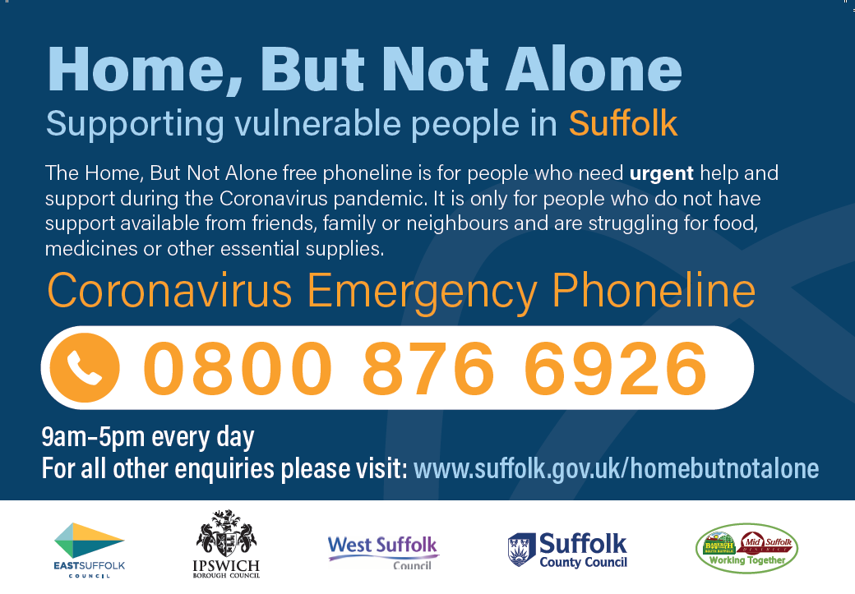

East Suffolk responds to new restrictions
East Suffolk Council has confirmed that key services will continue despite the new restrictions introduced to help combat the Covid-19 pandemic. However, we are asking residents to continue doing their very best to help combat the virus.
While some changes and adaptations have been made to ensure that the Council adheres to the new guidelines, the priority remains that services continue to be delivered as normally as possible while also supporting the efforts to reduce the virus in East Suffolk and the wider county.
So, for example, while our Leisure Centres and Marina Customer Service Centres have unfortunately had to close temporarily in line with government guidelines, waste collections are to continue as normal, public conveniences will remain open and grounds maintenance will not be affected.

New Chairman elected
East Suffolk Council elected its new Chairman at virtual Annual Meeting, which was held on 23 September.
Cllr Keith Robinson, who represents the Oulton Broad ward, will be Chairman for the remainder of the 2020/21 Municipal Year, taking on the post from Cllr Colin Hedgley.

New ‘Local Plan’ approved
East Suffolk Council have adopted the Suffolk Coastal Local Plan – an ambitious strategy to guide and manage new development for the former Suffolk Coastal area in a sustainable and plan-led way.
It proposes the delivery of at least 6,500 jobs and 9,756 new homes over the period to 2036, supported by the delivery of appropriate infrastructure whilst also setting out an approach to protect, maintain and enhance the high quality built, historic and natural environment, and mitigate and adapt to climate change.
To achieve this strategy, employment sites and residential sites have been identified in a variety of locations to realise the opportunities that exist across the Plan area, including the allocation of two new garden neighbourhoods at North Felixstowe and South Saxmundham.
The Plan will sit alongside the Waveney Local Plan which was adopted in March 2019, and the Local Plan for the Broads (prepared by the Broads Authority) which was adopted in May 2019, together providing up to date plans across the whole of East Suffolk.

People encouraged to stay safe on our coast
A campaign was launched end of October to remind residents and visitors about the importance of staying safe on our coast.
Throughout the Covid-19 restrictions, and particularly since early summer, the Council’s Coastal Management Team has received almost daily reports from concerned landowners, businesses and the community about people climbing through eroding cliffs, climbing on top of sea defences and ignoring signs warning of potential dangers.
The campaign encourages people to visit the coast and enjoy all that there is to see and do but also aims to educate people to take care whilst they are there to ensure that their visit is enjoyable and safe. The campaign launched on social media and with posters and information in prominent local places.
Anyone who notice anything unusual or dangerous about cliffs or any coastal defences, should email coastalmanagement@eastsuffolk.gov.uk. In an emergency always call 999 and ask for the Coastguard.

Bawdsey in particular has suffered a large amount of cliff erosion so its important we stay safe if enjoying our beaches and coastal walks .

Major funding boost to help tackle homelessness
East Suffolk Council has been awarded £93,312 in funding as part of the Government’s Next Steps Accommodation Programme, to help vulnerable people housed during the pandemic stay in accommodation. Working closely with key partners across the district, the funding will enable the Council to continue to provide accommodation and support for vulnerable people placed under the Covid-19 provisions, including assisting with offers of accommodation in the private rented sector; offering employment and skills support through a personalised, one-to-one coaching service delivered by Access Community Trust; and providing additional emergency beds during the colder winter months.

Comments invited on planning documents
East Suffolk residents are invited to have their say on three draft planning documents:
- The draft Cycling and Walking Strategy
- The draft Statement of Community Involvement (SCI)
- The draft Recreational Disturbance Avoidance and Mitigation Strategy (RAMS) Supplementary Planning Document
All three consultations close on 30 November 2020 and comments can be submitted online, by email at planningpolicy@eastsuffolk.gov.uk or by post to East Suffolk Council, Planning Policy & Delivery Team, Riverside 4, Canning Road, Lowestoft, NR33 0EQ.

Suffolk Domestic Abuse Helpline – 0800 977 5690
I am also supporting white ribbon charity ( white ribbon day 25 Nov ) a charity this trying to end male violence against women by engaging with men and boys to make a stand against violence .
https://www.whiteribbon.org.uk/

James Mallinder
Deben Ward
Environment Portfolio holder

