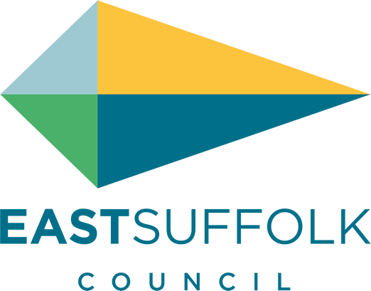

September 2021

Welcome to my monthly newsletter

East Suffolk bid to become City of Culture 2025
We have joined forces with Great Yarmouth Borough Council for a bid to become UK City of Culture 2025.
Our bid aims to showcase the region’s rich and multi-layered culture, its diversity, its people and their creativity, experiences, buildings and landscapes, opening them up to be enjoyed and engaged with by everyone and creating a cultural legacy for future generations.

It will play a key role in the efforts of both communities to overcome their challenges, helping local people to recover from the effects of the pandemic and forge new opportunities ahead, especially for young people.

This is the first time a collection of linked or neighbouring towns have been eligible to apply together, and the joint bid has won the support of the New Anglia LEP, Norfolk County Council, Suffolk County Council, Norfolk Community Foundation, Norfolk Chambers of Commerce, Suffolk Chambers of Commerce, the area’s three local MPs and many other major regional public sector stakeholders, arts and community organisations.

The decision on whether our bid has made it onto the long list will be announced in early September 2021, with the UK City of Culture 2025 winner being announced in May next year.

Suffolk Climate Emergency Plan
The whole of Suffolk – SCC , Districts and Borough have come together to try and show a direction on the environment through :

https://www.greensuffolk.org/app/uploads/2021/07/Suffolk-Climate-Emergency-Plan.pdf

The direction is slightly different to my vision – in East Suffolk we focus heavily on our biodiversity along with leadership and education.
However it will provide a strong focus for the whole of Suffolk
Personally I would like to see a East Anglia grouping - but that discussion will be for another day .

Former council offices back on the market
The former council offices on Melton Hill in Woodbridge have been empty for five years and following the end of contract with the site’s original developer, we are once again marketing the 3.23-acre site for sale to provide much-needed housing in this popular area.

To ensure that local people’s views are being heard and taken into consideration, we would like to see any potential developer coming forward to forging a close working relationship with the local community and Woodbridge Town Council.
Furthermore, we are committed to addressing the need for more affordable homes in the area and, as with any planning application of this size, the Planning Authority would expect any development to include provision for at least 33% affordable housing.

FelixFest – The ultimate weekend of family fun
To celebrate the Women’s Tour, one of the UK’s biggest sporting events, finishing in Felixstowe this October, we’re hosting FelixFest in partnership with Felixstowe Town Council – an ultimate weekend of fun for local people and visitors alike.
The celebrations will be taking place on the weekend of 8 - 10 October, kicking off on the Friday night with an outdoor cinema. The movie is yet to be decided, and all suggestions are welcome by email on leisure@eastsuffolk.gov.uk

The Saturday will see some of the world’s best cyclists racing to be crowned the 2021 Women’s Tour champion in the Final Stage on Sea Road.
Activities will be taking place on Saturday 9 October at the finishing line, prior to the Women’s Tour final stage, including a 10km bike ride, children’s races and lots of demonstration activities.

There will also be a Tour Village with stalls providing information, activities and representations from some of the sponsors of the Tour, a Pump Track for people to have a go on and entertainment and information talks on the podium over the weekend.

Changes to garden waste in the south of the district
Rules on what can go into garden waste bins in the south of East Suffolk have changed (1 September), aligning it with the rest of the district which has had the same arrangements in place for a number of years.

We wrote to every affected household in July explaining what was changing and why, and what can now go into the garden waste bins.

More information on these changes can be found on the FAQs on our Garden Waste page: www.eastsuffolk.gov.uk/waste/waste-collection-and-disposal/garden-waste/

Residents urged to check waste carrier details
Householders in East Suffolk are being reminded of their legal responsibility when disposing of their household waste, after a Suffolk resident was fined over £1,200 at a hearing at Ipswich Magistrates’ Court on Wednesday 18 August.

On 17 March 2020, our Customer Services Team received a report of three black bags of waste which had been left on the verge in Monument Farm Lane, Foxhall. During a site visit the next day, officers from East Suffolk Norse found that the bags contained household waste, including paperwork with a name and address.

When contacted, the individual claimed that the waste was removed from her home address by a third party, along with some scrap items. She was given six weeks to provide details of this person however she did not respond and on 15 May 2020, was issued with a £200 Fixed Penalty Notice, reduced to £120 if paid within 10 days. She failed to pay this notice, despite reminders being sent.

The perpetrator did not attend their court hearing, having written to the court asking for the case to be heard in their absence. The court found them guilty of breaching Section 34(2A) and (6) of the Environmental Protection Act 1990 and fined them £200 for the offence, plus £1,000 for costs and £34 for the victim surcharge, totalling £1,234.

Misc Ward issues
I have met with Stutt estate management to discuss the charging for carparking at Ramsholt - unfortunately there was no appetite to return to free parking . Signs have been logged as unsuitable and planning enforcement are looking into this .

There has been concern over the disruption to wildlife and large inappropriate vehicles across the Peninsula due to the Amazon film project .
Although I have had little interest in communication from the production company I am watching it closely and I will enforce any concerns if in breach.

I was interviewed on Jon Wrights Radio Suffolk prog earlier this month , it was nice to articulate my focus and concerns and if you fancy a listen : https://www.bbc.co.uk/sounds/play/p09tdvt9

And I attended the beautiful Sutton flower festival .

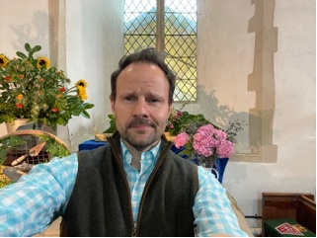

James Mallinder
Deben Ward
Environment Portfolio holder

